**14.0 Class Diagram**

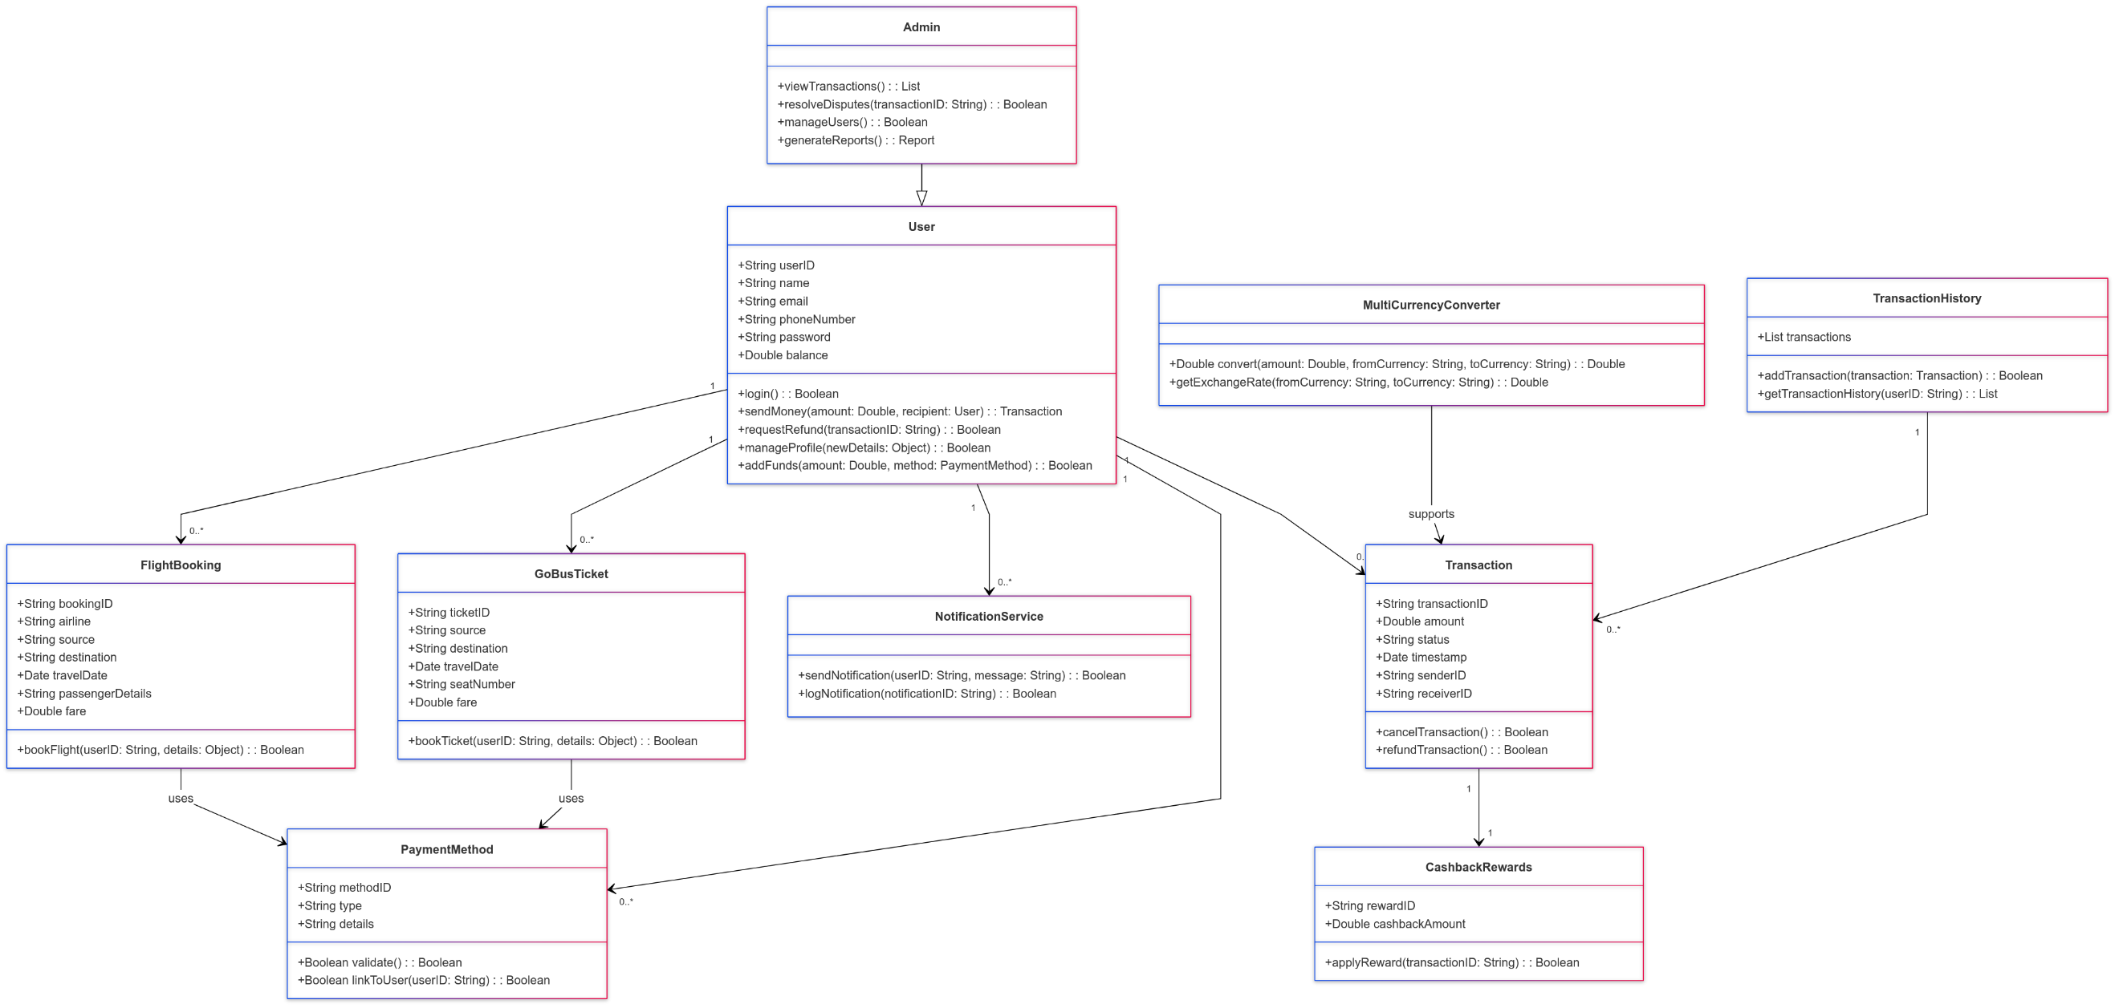

Fig:14.0 Class Diagram